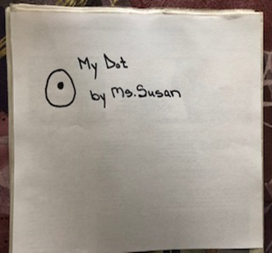 | 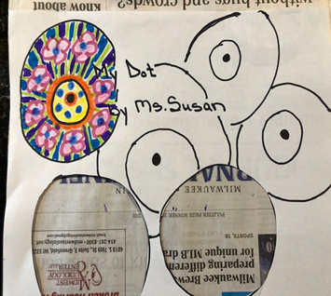
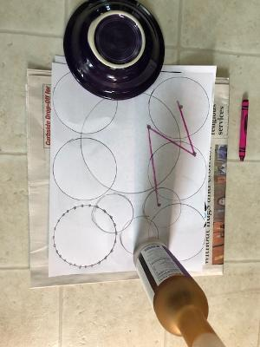 | 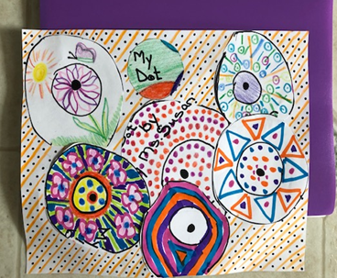
This is Ms. Susan from the Shorewood Public Library. This week we are going to celebrate a great book about creating art, titled, the dot by Peter Reynolds. This book is about a young girl who is learning to express herself through art. Each of us have our own unique ideas, feelings, experiences, and preferences, which we can bring to our art. Everything begins with one thought, one idea, or even one dot that comes from us and ends up as our perfect creation. So, let’s put our special thoughts of color, size, and shape into this magnificent ArtCart project. You can even ask others in your home to share some of their unique talents and put their dots, circles, or designs together with yours to make one big, beautiful art creation.

1-Start with one dot on a piece of paper.
2-Draw a circle around the dot. Add more dots to your paper. Draw more circles. Make dots into a circle.
3-Now decorate the circles with pens, pencils, crayons, paints, or markers. Cut out some of the circles and share them with others to decorate. You can use different items from around the house to trace the circles. For younger artists, just put dots on a page, and see if they can draw lines to connect the dots. What do the lines create? Color it.
4-This is the never-ending art project. You can glue, tape or staple all the circles on to another paper, creating a new picture. Draw lines in the background or add more dots. Make a game out of it, and have each person draw a dot on a page, then pass the page to the next person. They can add a circle, line, dot or decorate. Pass it on again, and see how many different works of art can be made. I hope you enjoy learning what can be created from a single dot. Oh, the possibilities!
Have fun, be well! Ms. Susan

